Are you interested in taking part in a focus group?

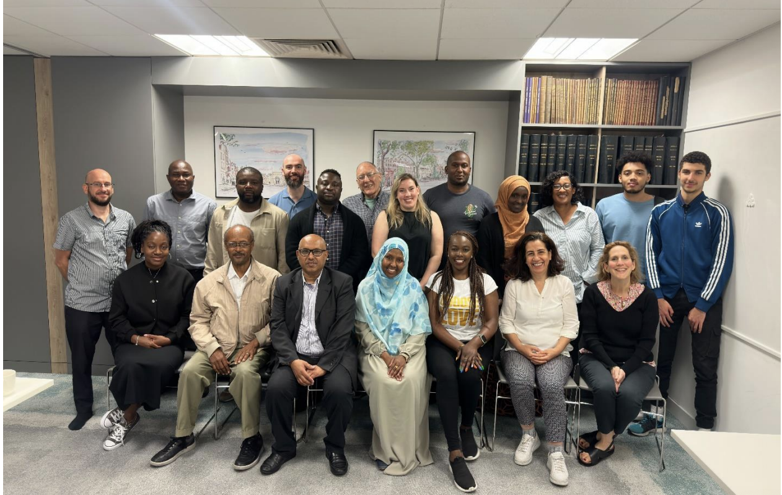
Image: A group photo of some of our funded groups, July 2023

Local funder, Cripplegate Foundation, is working with an organisation called Power With to carry out research to help us learn more about the lives and experiences of people living in Islington.

Each year, with the help of residents, Cripplegate Foundation makes grants to loads of local charities. Together with our partners, our aim is to reduce poverty and inequality in our borough and in order to do this better, we need your help.

We are looking for people to take part in a focus group. It will last one hour and the participants will receive a £15 voucher to say thank you for their time!
The focus groups are taking place on the following days:
- 28th September, 2-3pm, online
- 2nd October, 3-4pm, in person (at the Cripplegate Foundation offices)
- 3rd October, 10am-11am, in person (at the Cripplegate Foundation offices)
- 3rd October, 4-5pm, in person (at the Cripplegate Foundation offices)

We are particularly looking for people who may not usually be involved in consultation exercises or have their voices heard through public services.

Participants must be:
- aged 18 or over
- an Islington resident
- comfortable expressing themselves in English
- able to consent to taking part in the project

If you are interested, please email Delia on: delia.aguila@powerwith.org or call her on 07508970309 (phone call, text message or WhatsApp) and we can book you to attend an interview or focus group.

You can find out more about our work on our websites:
https://www.powerwith.org/ https://cripplegate.org/

