New Governors (Trustee equivalent)
Information Pack

Contents
About Cripplegate Foundation and Islington Giving
About our Governors
How to Express an Interest, and the Process

Deadline for Expressions of Interest: 12 October 2022

For an informal discussion please contact Allyson Davies at
CFIG@allysondavies-consultant.com
or call 020 7828 3855 or 07968 556 164

For background information on Cripplegate Foundation and Islington Giving, see:
www.cripplegate.org
https://islingtongiving.org.uk/

Cripplegate Foundation is committed to best practice in
Equality, Diversity and Inclusion

Cripplegate Foundation is a registered charity, number 207499,
with its registered address at 13 Elliott’s Place, London N1 8HX

BACKGROUND BRIEFING

We transform lives for people in Islington.
We’re independent, and trusted.

Are you interested in making a positive difference in Islington; helping to effect change and tackle issues related to poverty and inequality in our borough?
Can you help amplify the voice of those we work with, through your personal or professional experience?
Could you bring diversity to our board so that we better reflect the community in which we work?
Do you have volunteering or charity experience?
Are you able to commit the time required to make the most of joining us?
If any of the above apply to you, then becoming a Governor of the Cripplegate Foundation may be the right opportunity for you. Full induction and support would be provided, so don’t let a lack of experience of being a trustee or governor deter you from reading more…

Our vision for Islington is of an equal borough
where everyone can enjoy a life free from poverty
and access the many opportunities on offer in their local area.

About Cripplegate Foundation and Islington Giving
Cripplegate Foundation has grown from a local grant-making trust established over 500 years ago in Islington. We now have an endowment of some £45 million; together with Islington Giving, we give out grants of around £1.9 million a year in the local area. We want to improve access to opportunities and make lasting change. Our focus for the next three years will be to:
- Listen, learn and act - to better understand the needs of local residents and adapt our grant making
- Raise funds and make grants - maximising the money and resources available to support residents and communities
- Amplify local voices - to promote and encourage greater equity and access to opportunities across Islington
- Aim for organisational excellence - to achieve our strategy and our longer-term impact
Islington Giving now forms a significant part of the work of Cripplegate Foundation. It brings together a network of coalition partners, individuals and businesses committed to addressing poverty and inequality and making Islington a better borough to live in for everyone. In collaboration with local residents, Islington Giving raises funds, gives grants and shares local knowledge and expertise. The main aims are to:
- Raise more funds to support local projects that create a greater sense of community in Islington
- Increase access to opportunities for all residents in Islington
- Reduce isolation and create connections for all residents in Islington
Share decision making more equally with residents and, as a coalition, share our learning more widely. Islington Giving has its own board, which includes some Cripplegate Foundation Governors. Cripplegate Foundation staff manage Islington Giving’s resources and programmes, including fundraising. In 2021 we raised £969,383. For more information on Islington Giving please read our Impact Report 2021.
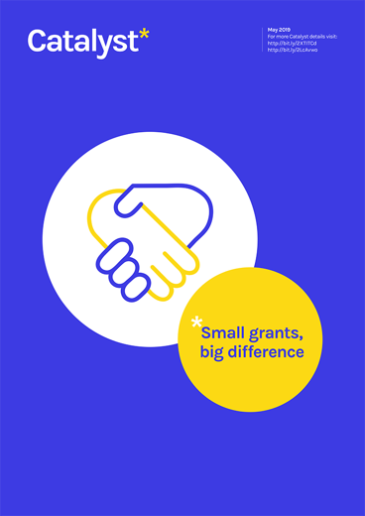
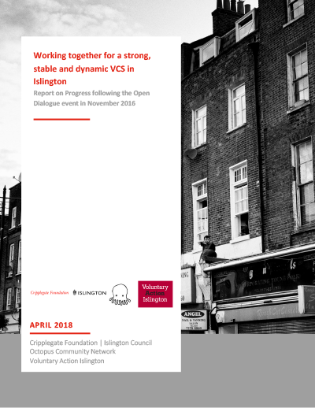
Cripplegate Foundation has a reputation for quality and innovation, and for its supportive approach to the development of local voluntary and community organisations. We have commissioned and published important research into disadvantage and inequality in Islington. This has provided the evidence base for the Foundation’s and Islington Giving’s strategy, partnerships and programmes.
Over the years we have achieved a successful record of spotting and seizing opportunities for new avenues of work, new resources and partnerships. We have become a major nfluencer in the grant-giving sector on a London-wide and national level and have achieved significant innovations, such as:
- Creating and developing Islington Giving, which has shone a light on poverty and inequality and raised nearly £10million since beginning in 2010 to invest in local, innovative programmes.
- Pioneering place-based giving which has now become a widespread approach to funding and has been adopted by other funders.
- Partnering with Islington Council to promote community development through the Community Chest, a small grants programme.
- Establishing Young Grantmakers, supporting young people to run their own grants programmes.
The Foundation has a small, committed, passionate and talented staff team of 13. It is constituted by a Charity Commission Scheme and has a single corporate trustee with 16 directors, known as ‘Governors,’ who make a huge contribution to our success. Over the coming months, a number of our existing Governors will come to the end of their terms in office. So, we now need to find four new Governors to join our team; they will make an important contribution to our work and future.
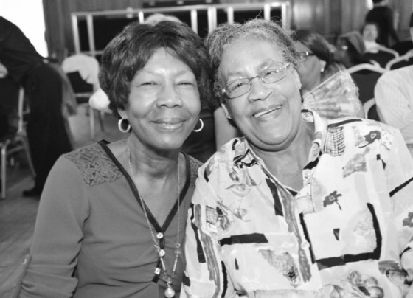
Why Islington?
Islington is a proudly diverse Borough where people from all faiths, nationalities and backgrounds have made their homes and people really embrace their local community and 91% of residents say that they enjoy living in Islington. However, there is a huge gap between the ‘haves’ and the ‘have nots’, for example:
- 43% of children in the Borough live in poverty, the highest child poverty level in London. Children growing up in Black, Asian and other minority Ethnic Groups households in Islington are more likely to be living in poverty in comparison to white children.
- The Borough ranks fourth highest in London for older people living in poverty. Older people make up a significant proportion of Islington’s social housing households and they have a considerably lower income than the rest of the borough.
- And, even before the pandemic, Islington ranked the fifth highest in London for loneliness and 1 in 6 people were living with a diagnosed mental health condition.
Cripplegate Foundation and Islington Giving aim to help address these issues.

Why we need new Governors
We work with, not for, the groups we fund. The challenges around tackling poverty and the ways in which the community respond to them are ever changing and the innovation and creativity comes from the grassroots. We know that we need people on our board who genuinely reflect the local community if we are to respond and work alongside it with integrity and understanding. We also need to ensure that our board reflects the diversity of Islington, again because we understand and appreciate that this will lead to better decisions and more effective grant making in the local area. The new Governors will help us ensure the continued relevance of our work and that the creative potential and voice of the community is integral to our work. We will be looking for at least four new people to join us from this round of recruitment.

A little about our Governors
The Governors are motivated by the community and the people and projects that Cripplegate works with. There is a strong sense of respect for them, and the Governors are inspired by their vision, passion and energy to deliver positive change in Islington.
The existing Governors come from a wide range of backgrounds. They are an interesting group and bring a range of life and professional skills and approaches. Together they have considerable experience of being responsible for the good governance of a grant making foundation. The Governors share a passion for and commitment to the aims, values and work of the Foundation and work effectively and collaboratively, both together and with the executive team. We are ready to share our experience, supporting new Governors to get to grips with the Foundation’s way of working and approach to grant making. We are also keen to learn from the new governors and hope that they will bring diverse backgrounds and approaches, knowledge and experience for us to grow and develop as a group.
We will offer a full induction programme, and mentoring, for people who have the qualities and experiences we are looking for. You don’t need to have experience of being a trustee or a background in grant making: these are skills which can be developed, so please don’t let a lack of experience in these areas put you off from applying.

Being a Governor
Governors bring their backgrounds, experiences, time, and skills to the role: we work hard and are a committed and supportive group, working closely with the staff team to ensure the best possible outcomes for those we work alongside.
There is plenty of space for laughter and camaraderie too. Governor satisfaction derives from being able to support extraordinary people and projects in the area. We like to listen carefully, and help, with openness and humility. Building Governors’ understanding of the groups we fund is crucial, and getting to know projects (for example through presentations and discussions with funded groups at the Foundation's board meetings, and visits to local projects' own activities) is a key activity and one which all Governors will be encouraged to do as part of our ongoing development. There is a time commitment, and we are hoping to spend more time in person again in the future, so you’ll need to be able fit us into your life. That said, we do offer flexibility and we try to accommodate as much as possible to help Governors fulfil their roles well.
We are genuinely encouraging a wide range of people to come forward and cannot emphasise enough about how your background, life experience, approach and values are more important than any knowledge or experience of grant making, or of being a trustee elsewhere. We are not being specific about the skills and experience you might bring, as the right people can be supported and inducted in becoming a Governor. However, what follows should give you an idea of the kinds of responsibilities you can expect to be engaged with, alongside your fellow Governors and with the support of a professional team.

Strategy and Planning
- Ensuring that the organisation delivers the best possible outcomes for the groups it works with. This means being responsible (with the support of the staff team) for the direction the organisation takes. This can involve being involved in discussions and decisions around strategy, setting goals and targets and holding the team to account for delivery.
- Ensuring that the organisation is meeting requirements around charity law and best practice, with support from the staff team and professional advisers.

Decision Making
- Approving the grants made by the Foundation and making sure that the resources are used appropriately and effectively, and exclusively with Islington and a small, defined area of the City of London.
- Being collectively responsible for the organisation’s resources: financial, human, the building and IT.

Relationship Building
- Building collaborative and collegiate working relationships with other Governors, members of the staff team, our partners and the local community groups and organisations.

Some qualities, abilities and skills we are looking for
We believe that to enjoy Cripplegate’s way of working, a new Governor will need high levels of emotional intelligence, empathy and integrity and an understanding of what smaller, locally based organisations might offer their communities.
We would like to hear from candidates from a wide range of backgrounds who have a demonstrable commitment to supporting people in Islington to drive their own positive change. We want people who feel a connection and passion for the kind of work we do.
We also have three other hopes for this recruitment campaign.
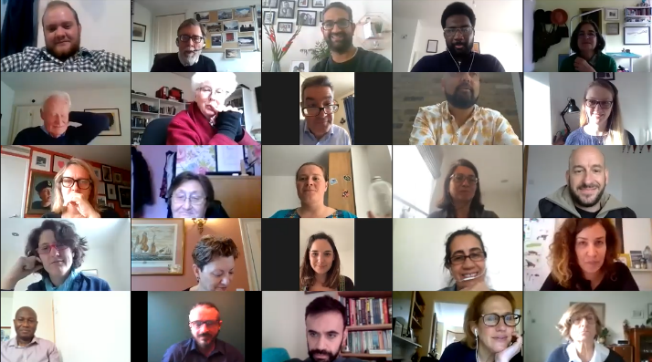
Firstly, we would like to bring people onto the Board who have experience and knowledge of the kind of organisations and groups we fund. Your experience of the community could come from any number of places. You may have grown up in the area, or you may live here now. You, or a loved one, may have lived experiences of some of the issues we tackle. You may work for a grassroots organisation like those we work with, or you may have experience of community activism. Or perhaps you work in the area. The reason we want to amplify the community voice in this way is because we know that it will deepen our understanding and have a positive impact on the work of the Foundation and will help us to be more authentic advocates for the needs of the community.
Our second hope is to have a trustee board that reflects the diversity of the local community, so we especially want to hear from candidates from a wide variety of ages, backgrounds and ethnic groups, people who have experienced poverty and disadvantage first-hand, and people who have a disability, or who have close experience of others with disabilities.
Finally, the culture of Cripplegate means that Governors become engaged with our work. Governors often join other committees, aside from the main board and there is potential, for those who are interested, to take on more responsibilities such as chairing a committee, becoming a Vice-Chair and even the Chair of the board in time. In short becoming a Governor is not a tick-box exercise, it’s a relationship. So, you will need to be able to commit time to the role and be able to attend the meetings regularly. We are currently using a hybrid model for meetings and whilst this is likely to remain, our hope is that there will be more in-person contact in time. In order to give you a clear idea of the time commitment involved, the current Governors say that on average it takes about four hours per month to get the most out of the experience, although this can vary depending on the governor and number of committees they have volunteered for.
In addition, these are some of the qualities, abilities and skills we are looking for in our new governors. We hope that each of the new governors will bring a some of the following:
- Passion for our work
- Vision and creativity
- Exceptional listening skills, with an ability to speak your mind
- Integrity and commitment
- A team player
- Emotional intelligence
- A willingness to learn about and take responsibility for the legal duties, responsibilities and liabilities of being a trustee/governor
If you feel that we are describing you in any of the above, then we’d love to hear from you. Your interest would be greatly valued and appreciated.

The annual pattern of meetings
Governors meet as a full board four times a year. You will also have the opportunity to join various sub-committees and task groups set up to consider aspects of our strategy, and also to represent the Foundation on one of Islington Giving’s committees or another of our local partnerships.

Next steps
If you would like an initial, informal conversation about these roles please contact Allyson Davies, who is working with us to bring new governors on board. You can email Allyson at:
CFIG@allysondavies-consultant.com or call her on 07968 556 164.
To express an interest in becoming a governor, please write a letter, addressed to Cripplegate’s Co-Chairs, Nezahat Cihan and Anne-Marie Ellis, explaining why you are interested and outlining what you would bring to the role. Please also supply a copy of your CV, and the Equal Opportunities Monitoring Form (download from this link).
Expressions of interest, the EO form, and your CV should be emailed to:
CFIG@allysondavies-consultant.com.
If you have a connection to Cripplegate or Islington Giving, you are very welcome to apply, but please explain this connection in your covering letter. Once we have reviewed your expression of interest—and we will do this on a rolling basis—Allyson will let you know whether we can take it forward. The next step will be an informal meeting with Allyson, which will provide you with an opportunity to find out more about Cripplegate and the role.
Following this, we will invite a number of people to an Open Afternoon with Cripplegate. This would be followed with individuals then meeting with some Governors and Allyson the following week.
This may seem like a long process but, given the level of contribution that Governors make, we think it’s important that both potential Governors and the team here feel that there is a positive match of values, a complementary skills-set, and a sense that we can all work well together.

Timetable

Send a letter and CV | 12 October
Informal meeting with our advisor, Allyson | Weeks of 24 and 31 October
Open Afternoon with Cripplegate | 16 or 17 November
Meeting with selection panel | 21 or 22 November
First board meeting | 7 December

Data Protection
The personal information that you provide will be used to process your expression of interest with the Cripplegate Foundation/Islington Giving. Personal information about unsuccessful candidates will be held securely for six months after the recruitment exercise has been completed; it will then be deleted. If your application is successful and you take up the role, the information will be used in the administration of your work with us. It will be kept secure and will only be used for purposes directly relevant to your work.

Any questions?
If you need any further information or you would like to discuss anything in more detail, please email CFIG@allysondavies-consultant.com or phone Allyson Davies on 020 7828 3855 or 07968 556 164.

We value diversity, equality and inclusivity. Applications are welcomed from those from underrepresented backgrounds, including but not limited to gender, ethnicity, age, sexual orientation and religion.

